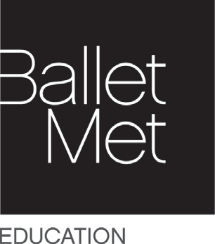

Education and Community Engagement Programs Overview

BalletMet’s Commitment to Dance Education Access
BalletMet is committed to being a leader in collaborative arts education efforts designed to enlighten and inspire today’s young people. We believe that dance is most valuable to the community when it is supported by quality educational initiatives. Our Education and Community Engagement programs positively affect the lives of children and adults throughout central Ohio. We make available to a large and diverse population the opportunity to learn about dance as a viable subject for intellectual growth, health and well-being, social development and lifelong learning.

BalletMet’s unique and interactive Education and Community Engagement programs provide substantive, curriculum-based and age-appropriate offerings designed to fully engage students and teachers in the learning process. A strong emphasis is placed on intensive, multi-week programs to increase educational impact on students. Meaningful classroom learning tools and audience development programs celebrating the rich cultural heritage of dance are also offered.

BalletMet’s Community Engagement
BalletMet aims to provide free or low cost opportunities for participants to create, learn and participate in dance while receiving the highest quality instruction. Through our Soar on Saturdays and Discover Dance Scholarship Programs, we strive to make dance more accessible by removing barriers and encouraging a life-long appreciation of the art.
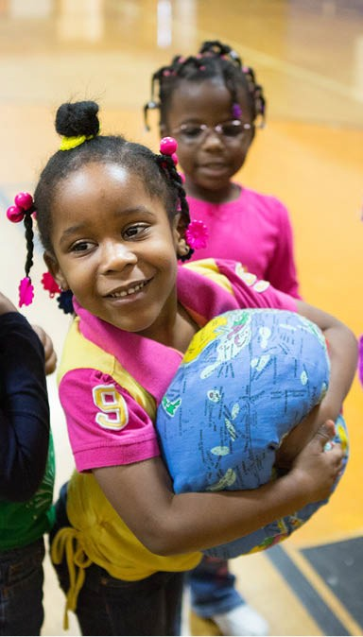

BalletMet’s Commitment to Anti-Racism and Equity

We believe that art can inspire change. Our hope is that BalletMet will serve as a vehicle, a comfort and a celebration of our community and all humanity. As with many arts and cultural organizations around the country BalletMet stands in solidarity with those taking action against systemic racism.

BalletMet stands with the Black Community, People of Color, and other Marginalized Groups. As an organization and an art form, we recognize that there is much work to be done to not only understand where we have missed the mark but also to continue to learn and grow to forge a brighter path ahead, together. We are thoroughly examining our practices to best position ourselves to make direct and enduring progress combating racial inequality within our organization and community. We have designated a Senior Level position on our staff to prioritize and uphold ongoing institutional change. Further, we are working towards developing a comprehensive initiative addressing anti-racism and equity.

We have collectively identified the purpose of our initiative, who it impacts, and why it matters. These are inclusive of but not limited to:

• Represent our community through the art form of dance to elevate the human experience.

• Establish a Coalition consisting of community leaders, company dancers, staff, and organizational leadership to review and advise BalletMet on its initiatives addressing Anti-Racism and Equity.

• Evaluate all aspects of our organizational structure including governance, policies, programming, marketing and communications, education, and staff training to identify knowing or unknowing behaviors and biases that contribute to systemic racism practices.

• Develop, support, and implement ongoing Anti-Racism and Equity training and dialogue for the organization and its people.

• Continual organizational review of artistic programming, company collaborations, and educational programming, to ensure alignment with the Anti-Racism and Equity initiative

BalletMet’s Dance Education In-School Programming
Research demonstrates that students benefit academically and socially from regular, sustained involvement in the arts and students in art-rich environments experience a positive impact on academic ability, socialization and engagement in school. All of our Dance-in-Schools programs create an opportunity for students to repeatedly connect with the art of dance through movement based curriculum that also focuses on age-appropriate cognitive, physical and social-emotional development in alignment with Ohio Department of Education (ODE) Standards. Dance-in-Schools programs incorporate the development of skill sets such as:

- Creativity and critical thinking and problem solving; communication and collaboration
- STEAM and Language Arts literacy
- Executive function skills, accountability and leadership
- Social-emotional skills and self-care
- Interdisciplinary, project-based experiences

Students in experiential programs such as The Wiggle Jig and Moving into Literacy learn critical thinking skills as they observe and participate in dances as well as how to effectively communicate and critique others. In all programs, social emotional skills are enforced as core skills to ensure participants learn how to work together with others.

PROGRAMS

Morning at the Ballet Performances for Students

*Note: Due to the COVID-19 pandemic, Morning at the Ballet will not be available for the 2021-2022 school year.
Program Goals:
- Through response and reflection, students will:
  - Demonstrate inquiry skills when stating and supporting their views about dance.
  - Critique a dance based on how effectively the formal, technical and expressive aspects communicate a theme or idea.
  - Discuss personal reactions to dances viewed or performed and consider how these are informed by cultural and social influence.

BalletMet’s Morning at the Ballet provides area schools the opportunity to attend a professional performance of a ballet in a theater setting. Students gain firsthand experience with dance as a theatre art. To supplement this experience, teachers are given educational materials including an online study guide and PowerPoint presentation to help students better understand ballet and dance concepts.
Teachers are encouraged to incorporate this experience into their curriculum and encourage students to write or talk about the performance afterward.

The Wiggle Jig Early Childhood Program- For Students Ages 3-5
Program Goals:
- Cognitive:
  - Improve early math skills through rhythm and counting activities.
  - Increase attention span through repetition of movement activities that gradually over time increase in complexity and length.
  - Build executive function skills.
- Physical:
  - Improve fine and gross motor skills by engaging children in age-appropriate movement activities that are designed to stimulate the physical senses.

- Social Emotional:
  - Improve social emotional skills through small group work and increasing attention span.
  - Increase understanding of body language and nurture young children’s ability to appropriately express their emotions.
  - Expand the worldview of preschool children by introducing them to culturally responsive experiences that are outside their typical environment.

A young child’s success in school and life is impacted by their readiness to begin kindergarten. The Wiggle Jig uses an innovative and comprehensive approach to help improve physical, socio-emotional and cognitive development, literacy skills and creative expression. Through the infusion of movement and dance, the program provides experiences and tools to help guide a child’s social growth from an individually-centered world to one that includes being a part of a larger group such as kindergarten. As activities become more group-oriented, it is often difficult to keep a child focused and on-task. By offering 10 classes over the course of a 5 or 10 week session, The Wiggle Jig residency allows for the repetition of movement activities and a more sustained presence and incorporation of the curriculum into classroom studies, often resulting in a child’s increased attention span. The Wiggle Jig age-appropriate creative movement activities also help improve gross motor skills while simultaneously teaching children to express their emotions more effectively. Additionally, classroom teachers receive professional development focused on how to integrate into their everyday classroom experience developmentally appropriate movement practices and tools to assess learning through observation of non-verbal behaviors.

Moving into Literacy - For Students Grades 1-5
Program Goals:
- Encourage active and consistent use of integrated curriculum by K-5 grade teachers and specialists during academic classes coinciding with the residency.
- Support student engagement in learning through cognitive, physical and affective learning opportunities designed to encourage creative and problem-solving skills.

Learning to read and write with a twist- and a hop, skip and jump- BalletMet’s Moving into Literacy program infuses dance education into ODE English Language Arts Standards to positively impact literacy. Participating students study pieces of literature and create their own works from dance to writing over the course of this 8 week residency program.

Results from the pre and post writing assessments used to evaluate Moving into Literacy’s impact on skills development suggest the following:
- Students show overall improvement in their writing.
- Students are more original and imaginative in their post-writing samples.
- Students are clearer and more consistent in their post-writing message/themes.
- Student writing samples show improvements in the use of adjectives and adverbs.

BalletMet Yoga, Meditation and Mindfulness Program
BalletMet offers beginner yoga and meditation classes taught by Yoga Alliance certified teachers for K-12 students and adults. Yoga teachers are also trained in evidence-based iRest® Yoga Nidra Meditation and mindfulness techniques. The Beginner Yoga curriculum fundamentals focus on warm-ups, asana, breathing and relaxation. In addition, some components of meditation and mindfulness are shared with the students. At this level the focus is on learning body awareness and the skills of relaxation and stress management within a wide range of poses and practices. This curriculum offers the viewpoint that yoga is part of an ancient practice and that by using certain methods we are participating in cultural practices with respect to the culture. This curriculum aligns with Ohio Department of Education Physical Education Standards 1-3.

BalletMet 2 Movement Makers Lecture Demonstration
Program Goals:
- Expand visibility, awareness and knowledge about dance as a profession.
- Introduce students to the craft of creating a work of art.

Founded by Edwaard Liang and Ambre Emory-Maier in 2014, BalletMet 2 is a Dance Academy performing company of dancers who train daily, rehearse and perform season repertoire with the BalletMet professional company to develop the expertise required for a professional career and being ambassadors for dance. Additionally, BalletMet 2 is designed as a workforce development tool that brings dance to the larger community including schools, civic organizations, festivals and special events. The interactive Movement Makers experience is performed in a gym, auditorium or multi-purpose room and includes performance, narration, audience participation and a question and answer opportunity.

Soar on Saturdays
Program Goals:
- Offer students exposure to a variety of dance class styles.
- Develop cultural literacy for young people to equip them with a life-long love of dance and the arts.
- Identify highly talented students to be trained in classical ballet and other dance styles.
Soar on Saturdays is a dance access program providing children ages 8-12 the opportunity to explore movement over the course of a free six-week dance class. Four different styles of dance are offered at a number of six-week sessions throughout the year. At the end of each six-week session, students are given the opportunity to share what they have learned with parents, friends and family at an in-studio demonstration. Students are given a free t-shirt and tickets to a BalletMet performance.

Conclusion
By offering a variety of dance based Education and Community Engagement programs, BalletMet strives to make quality dance instruction and performing arts experiences accessible, inspiring and relevant to a large population. Through stewardship, educational rigor and artistic excellence we are dedicated to inspiring continued personal growth and lifelong learning in dance.
